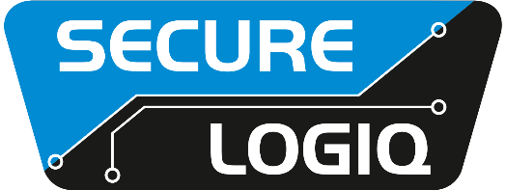

January 2022 For Immediate Release

Secure Logiq and Seagate join forces

Croydon, UK… Secure Logiq and Seagate are bringing together their combined strengths to create the ultimate storage solution for the video surveillance industry. This partnership will draw on Seagate’s world-renowned expertise in very high-density storage applications and Secure Logiq’s cutting edge understanding of the surveillance industry.
This new partnership provides the perfect solution for security professionals in the Middle East where retention times for CCTV footage are comparably longer than in other territories and exacting standards mean that second-best will never do. The collaboration will see Secure Logiq’s management servers, processing servers and client machines all designed and optimised for the application and combined with Seagate’s SAN storage units which offer large storage, resilience, expandability and vertical integration.
The combination of two of the world’s leading storage solution providers has created a “best of both worlds” scenario for their mutual clients as it has created an end-to-end solution which is designed, supplied, tested and supported by experts in HD surveillance and data storage.
“This is a powerful combination that will deliver real advantages for surveillance systems users across the whole Middle East,” said Secure Logiq’s Robin Hughes. “The benefits are there for everyone to see. Seagate has excellent products for storing large volumes of data and we have the understanding of the market to add real intelligence to a surveillance system. Together, can deliver a complete solution that will revolutionise how HD surveillance video is stored in the region.”
Secure Logiq and Seagate will be highlighting their new partnership at Intersec on Booth S1-E46.

For further information visit: www.securelogiq.com
####

Press Contact:
James Ling, The Inside Story
Tel: +44(0)1892 525141
Email: james@gettheinsidestory.com

About Secure Logiq:
Since 2011 Secure Logiq have been developing the missing piece of the HD surveillance jigsaw, servers specifically designed for HD surveillance. A new concept in the surveillance industry, our team of technical experts have over 150 years of both IP CCTV and server experience and boasts respected thought leaders from both the HD Surveillance and IT hardware industries.
In a short space of time Secure Logiq have become the world's leading independent manufacturer of servers, workstations and client machines optimised for HD Surveillance and Video Analytics applications.
Secure Logiq's company ethos is based on four core principles - to provide the Fastest Performance, the Biggest Storage, the Most Resilience and the Best Value in HD video processing, viewing and storage technology.

About Cloudforests.ie
Launched in 2020, Cloudforests is a social enterprise creating new forests for the planet along Ireland's wild Atlantic Way featuring live internet video streaming. It has so far planted over 21,000 trees for the planet at Lahinch and when the sun sets on the next planting day, another 14,000 trees will be added to that total.

